**Scope Management Plan**

**<I.O System>**

**Asia Pacific College**

**3 Humabon Place, Magallanes ,**

**Makati City**

**April 2023**

**Table of Contents**

Introduction 4

Scope Management Approach 5

Roles and Responsibilities 5

Scope Definition 7

Project Scope Statement 7

Work Breakdown Structure 8

Scope Verification 9

Scope Control 10

Sponsor Acceptance 11

# Introduction

1. Collect Requirements – The project team will use a number of methods to collect, and the system's requirements should be documented via user interviews with the client, adviser and consultant meetings and subject professor meetings.
2. User Stories – The project team will create user stories to describe the functionality of the system from the perspective of the end user. These stories will be prioritized based on business value and will be used to guide the development process.
3. Scope Statement – The scope statement will be developed using the user stories created and requirements as input. It will provide a high-level overview of the project scope, including the deliverables, and constraints.
4. Scope Baseline - The user stories and scope statement will be added to a project management plan to create the scope baseline. It will be frequently updated as the project develops to allow for scope changes.

**Scope Documentation**: The scope of I.O System will be documented by the methods listed here:

1. **Requirements documentation:** The system requirements will be documented that outlines the system’s functional and non-functional requirements.

1. **Project management plan**: This will include information about the scope of the project, also includes scope statement and the scope baseline. Other relevant information about the scope of the project is also part of this project management plan.
2. **Change log:** This will be added and maintained to track all changes to the scope of the project, this includes the description of the change, project impact and required approvals.

**Scope Control:** The scope of this project is controlled throughout these following activities:

1. **Scope Verification:** The agile testing techniques will be the project team’s desired method to verify that the deliverables of the project will meet the requirements and align with the scope statement.
2. **Scope change control:** Any changes to the scope of the project will be directed through a formal change control process, which will include an assessment of the impact on the project schedule, budget, and quality.
3. **Scope change review:** This will be held for each change request to

ensure that the change is necessary, feasible, and aligned with the project objectives.

# Scope Management Approach

1. Authority and responsibility for the scope management will be in the hands of the project manager of the group concave which is Stefano Franco Binay. He will be the one setting up appointments with the project adviser, which is Miss Gardon and also the clients to manage the project’s scope.
2. The scope statement, Work Breakdown Structure and the Statement of work will be the ones defining the scope of the project. With these documents, it will explain the tasks and requirements and then it will be reviewed by the project sponsor and other stakeholders before the work begins.
3. The scope is measured using quality checklists, measurements of work performance and regular monitoring of project’s advancement in relation to the original scope. Once there are differences from the scope baseline, it will be addressed to the scope change process.
4. The scope change process for Concave’s I.O System will require the project manager to send a request for scope change that needs to be approved by Ms. Roselle Gardon and it will be approved lastly by the project sponsor. Any changes brought to it will be checked to ensure that it is aligned by the project objectives.
5. The completion of the Inventory System and Ordering System project for Torrecamps Company will be authorized solely by the project client, Torrecamps Company. The project will only be considered complete when Torrecamps Company approves the system's functionality and determines that it meets the project goals and objectives. Any changes or modifications to the project scope or timeline must also be approved by Torrecamps Company.

# Roles and Responsibilities

|  |  |
| --- | --- |
| Project manager | The project manager oversees and approves scope adjustments in along with defining and documenting the project's scope. |
| Product owner | The project manager oversees and approves scope adjustments in along with defining and documenting the project's scope. |
| Project team | The project team is in charge of confirming the project's scope and, if necessary, submitting change requests. |
| Project team | Stakeholders oversee offering feedback on the project's requirements and scope as well as authorizing changes to that scope when necessary. |

# Scope Definition

The scope of the project includes the development of the system which is named I.O System. The proposed system will implement an inventory and ordering system. The system includes a website that will show the selling items of Torrecamps Marketing. This project will help in automating their transaction process and allows the user to order within the system, which is far more efficient.

# Project Scope Statement

Product Scope Description – The team is tasked with developing an inventory system and ordering system for their client, which is Torrecamps Marketing. This will automate the transaction and allows the users to order inside the system which brings more efficiency and removes the inconvenience of manually handling their transactions and inventory stuff. The I.O System is an inventory and ordering system. The website will be presenting the items that Torrecamps Marketing is selling. Every order will be recorded into the inventory and ordering system.

Product Acceptance Criteria

The I.O System will be completed and accepted once the group and the system meet the following criteria.

1. All features that are present in the project scope must be already fully developed
2. The proposed system must be integrated to the client's part
3. The project must be finished documented and there will be user manuals created.

**Project Deliverables**

Upon the successful conclusion of the project, the subsequent deliverables will be provided:

* A fully operational system.
* User manuals and training materials.
* Documentation about the proposal.
* Any other deliverables as outlined in the Project Scope Statement and agreed upon by the Project Sponsor.

**Project Exclusions**

These tasks are beyond the scope of the project:

1. For the mobile application, it is limited only to android OS.
2. The application will only include Cash-On-Delivery (COD) as their means of payment.
3. For walk-in customers the admin will manually create their order using the ordering system developed by the group.

**Project Constraints**

The following limitations will affect the project:

1. Budget
2. Timeline
3. Torrecamps’ existing business processes and constraints

**Project Assumptions**

The following assumptions will be considered during the project's development:

1. Torrecamps has an existing IT infrastructure that can support the new system.
2. Torrecamps' staff members are adequately trained to use the new system.
3. The project team has access to all the necessary data and resources required to develop the system.

# Work Breakdown Structure

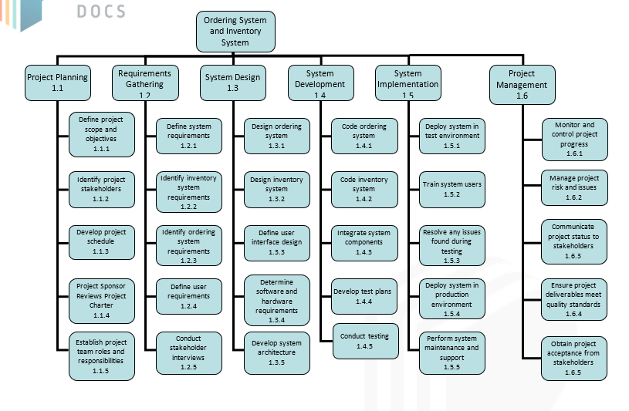**Figure 1.1, *Work Breakdown Structure (WBS)***

# Scope Verification

The project team will use various techniques for scope verification to guarantee that the Dispatch Directory System project deliverables satisfy the original scope. These methods include:

**Quality Checklists**

The project team will use checklists that outline the essential requirements for each deliverable to be accepted. These checklists will be employed to ensure that each deliverable satisfies all necessary criteria before progressing.

**Work Performance Measurements**

The team will use work performance measurements to monitor and gauge the advancement of each deliverable during the development phase. This approach will enable the team to detect any possible issues or deviations from the original scope and take prompt corrective measures.

**Scope Baseline**

The team will establish a scope baseline, which captures a snapshot of the initial project scope. Any modifications to the scope must be recorded and authorized before being implemented. The scope baseline will be employed to ensure that the final deliverables align with the original project scope.

**Formal Acceptance**

Each deliverable will be formally accepted by the project sponsor, customer, and other stakeholders upon completion. This ensures that the project team meets the expectations of all relevant parties and allows any necessary feedback or changes to be made promptly.

Overall, it is critical that the project team maintains open communication and cooperation with the client and other stakeholders throughout the project to ensure that the deliverables meet the original scope and are formally approved.

# Scope Control

The project's deliverables and progress will be reviewed regularly as part of the scope control process to make sure it stays within the limitations of the Project Scope Statement, that sets forth the initial project scope. Any changes from the scope will be reviewed and checked then if necessary, changes to the scope will be documented and approved using the established process for scope changes. The project manager will be in charge of monitoring the project's scope. To make sure the project stays on track and within its limits, the scope will be reviewed regularly. The project manager will also be in charge of making sure that any scope changes are properly documented and will be informing any changes to the parties involved.

The scope control process for the I.O. System will involve the following:

1. Any stakeholder or team member who notices the need for a change to the scope will make a scope change request.
2. The project manager and project sponsor will review the request for a change in scope to find out how it will affect the project's resources, budget, and schedule.
3. The Project Manager may accept or reject the request if the change appears to have a low impact. The project manager may accept or reject the request if the change is thought to have a high impact. The Project Sponsor has the authority to review and reject any low impact change request that has been approved or rejected by the Project Manager.
4. The Project Manager will develop an action plan to carry out the change, update the scope baseline, and inform every relevant stakeholder of the change if the request is granted.
5. The project team will proceed with the original scope if the request is denied.
6. To guarantee that the I.O System remains on course and within budget, an organized procedure for making changes to the scope baseline is important. To prevent scope creep and keep the project on schedule, any changes to the scope should be carefully evaluated and approved.

# Sponsor Acceptance

Approved by the Project Sponsor:

Date:

<Project Sponsor>

<Project Sponsor Title>